**Class: BCS V B/C Date: 04-12-20**

**Subject: Web Technologies Time Allowed: 60 Min**

**Instructor: Dr. Muhammad Imran Marks: 15**

# Sessional 2 Examination

1. What does the Mobile-first approach mean while designing a responsive web design? Write an efficient mobile-first CSS code which describes same CSS rule for font-size and distinct CSS rules for font-color for different screen sizes. The breakpoints for the screen sizes are provided below: **[Marks: 4]**
   * Screen width in the range 901px and Above
   * Screen width in the range 601 to 900px
   * Screen width in the range 301 to 600px
   * Screen width in the range 0 to 300px

**Answer:**

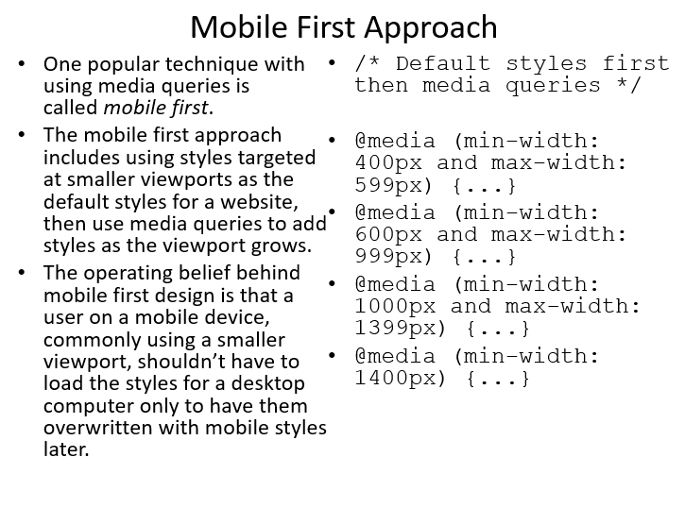

.container {

font-size: 12px;

color: #000;

}

@media only screen and (min-width:901px){

.container {

font-size: 13px;

color: black;

}

}

@media only screen and (min-width: 601px) and (max-width: 900px){

.container {

font-size: 14px;

color: green;

}

}

@media only screen and (min-width: 301) and (max-width: 600px){

.container {

font-size: 15px;

color: yellow;

}

}

@media only screen and (min-width: 0) and (max-width: 300px){

.container {

font-size: 16px;

color: red;

}

}

1. Write a JavaScript code to insert an element at the beginning and end of an array in JavaScript? **[Marks: 2]**

var array = ["apple", "banana", "orange", "pear"];

// insert at the start

array.unshift("grape");

// insert at the end

array.push("kiwi");

1. Consider the HTML code below. Write a script function so that the table data shows as indicated in the snapshot below: **[Marks: 4]**

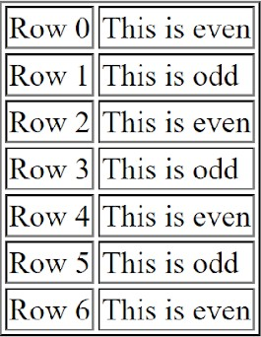

<!DOCTYPE html>

<html>

<head>

</head>

<body>

<table id = "theTable" border = "1">

</table>

<script type="text/javascript">

</script>

</body>

</html>

**Class: BCS V B/C Date: 04-12-20**

**Subject: Web Technologies Time Allowed: 60 Min**

**Instructor: Dr. Muhammad Imran Marks: 15**

**Answer:**

<!DOCTYPE html>

<html>

<head>

</head>

<body>

<table id = "theTable" border="1">

<tr>

<td>Row 0</td>

<td>This is even</td>

</tr>

<tr>

<td>Row 1</td>

<td>This is odd</td>

</tr>

<tr>

<td>Row 2</td>

<td>This is even</td>

</tr>

<tr>

<td>Row 3</td>

<td>This is odd</td>

</tr>

<tr>

<td>Row 4</td>

<td>This is even</td>

</tr>

<tr>

<td>Row 5</td>

<td>This is odd</td>

</tr>

<tr>

<td>Row 6</td>

<td>This is even</td>

</tr>

</table>

<script type="text/javascript">

</script>

</body>

</html>

# Sessional 2 Examination

1. Write an HTML code fragment that would produce the following DOM tree structure for an ordered list with an id of "rootNode" **[Marks: 3]**

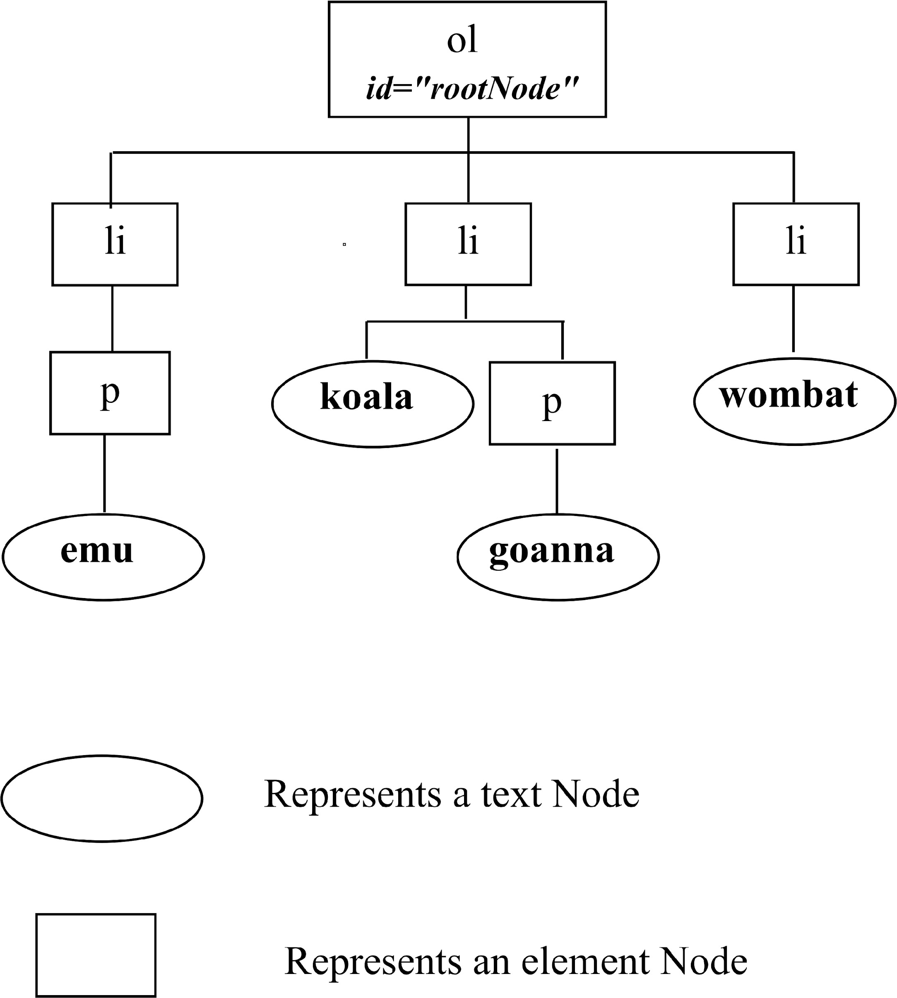

**Answer:**

<ol id="rootNode">

<li><p>emu</p></li>

<li>koala<p>goanna</p></li>

<li>wombat</li>

</ol>

1. Assume that we have an unordered list with three list-items. Insert one element both at the beginning and end of the already constructed unordered list in HTML. **[Marks: 2]**

**Answer:**

<!DOCTYPE html>

<html>

<head>

</head>

<body>

<ul>

<li>Item 1</li>

<li>Item 2</li>

<li>Item 3</li>

</ul>

<script>

var parentElement = document.getElementsByTagName("ul")[0];

var element = document.createElement("li");

element.innerText = "Item 0";

parentElement.insertBefore(element, parentElement.children[0]);

var elementLast = document.createElement("li");

elementLast.innerText = "Item 4";

parentElement.insertBefore(elementLast, parentElement.children[4]);

</script>

</body>

</html>

**Class: BCS V B/C Date: 04-12-20**

**Subject: Web Technologies Time Allowed: 60 Min**

**Instructor: Dr. Muhammad Imran Marks: 15**

# Sessional 2 Examination